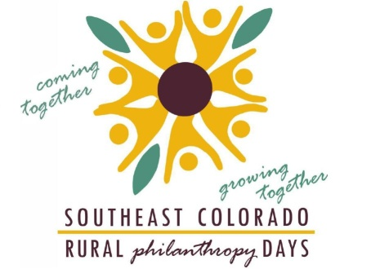

Dear Editor:

Every four years, Southeast Colorado Rural Philanthropy Days is held for our eight-county region. This time, it is being held in Trinidad, Colorado, September 24-26. This event brings many private and government grantmakers
to the region to learn about the great things we are doing and green light funding opportunities for our communities. The event also brings training and educational opportunities for our local nonprofits; opportunities which they may not otherwise have the opportunity to take advantage.

One of the greatest accomplishments of this event is that it brings local volunteers from Baca, Bent, Crowley, Huerfano, Kiowa, Las Animas, Otero and Prowers counties together. The local commitment brings with it local sponsors and vendors that help make the event successful and highlight the region.

As an example of the impact this three-day conference has on our eight-county region, it is important to note
that two years after an RPD event local nonprofits typically experience an increase of 140% in the average sum donated to rural nonprofits; and increase of 37% in the average number of grants to rural nonprofits; and an increase of 65% in the average amount per grant. More specifically, between the 2002 and 2006 conferences
total grant dollars to the region increased from about $665,000 to over $2,000,000 per year, from the core RPD funders. Total grant dollar amounts to the region were maintained at this level or slightly increased between the 2006 and 2010 conferences. Additionally, after the 2010 event 95% of attendees felt they had learned professionally applicable skills to bring back to their nonprofits and communities.

Our region’s nonprofits find greater success when they are able to find grants to fund their projects and this
event is a great way for all of our local nonprofits to get direct access to the people that will help bring funding
to our area. If you haven’t already marked your calendar for this important event, we strongly encourage you
to do so now! Registration opens July 14! And, be sure follow us on Facebook for all the latest developments surrounding this important event!

Thank you,
Southeast Colorado RPD Steering Committee

###

Rural Philanthropy Days is a statewide program managed by the Community Resource Center (CRC).

