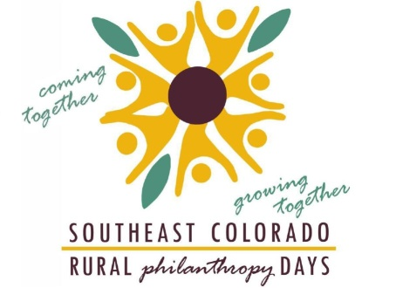

Public Service Announcement – Southeast Colorado Rural Philanthropy Days

Contact:
Alisha Hall, Event Coordinator
(719) 456-0106
SoutheastRPD@gmail.com

Attention all local non-profits…mark your calendars now! Southeast Colorado Rural Philanthropy Days
(RPD) is scheduled to come to Trinidad, Colorado, September 24-26, 2014! RPD is the premier training
and fundraising event for local grantseekers and statewide grantmakers to personally meet and discuss
rural challenges and potential funding opportunities for Baca, Bent, Crowley, Huerfano, Kiowa, Las Animas,
Otero and Prowers counties. This three-day conference provides opportunities to collaborate on projects, discuss funding resources and so much more! Event and registration information is available online at www.southeastrpd.org. Registration opens July 14! And, be sure follow us on Facebook for all the latest developments surrounding this important event!

Rural Philanthropy Days is a statewide program managed by the Community Resource Center (CRC).

